 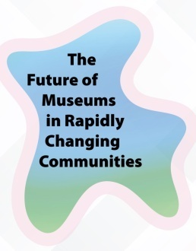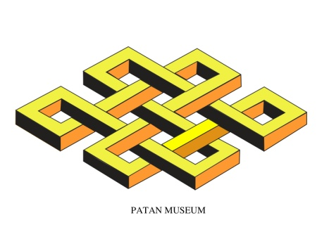

**INVITATION**

**Patan Museum Development Committee**

**Cordilly Invite to You**

**CELEBRATE INTERNATIONAL MUSEUM DAY 2025**

**18 MAY 2025, JESTHA 4 2082, 4PM, PATAN MUSEUM**

**Special Attraction Exhibition of Karunamaya Jata, Yala Art By Sushila Singh**